My name is Tanya, I’m 48 years old. I have Thalassemia Major and I have had Diabetes since I was 13.
Over the years I have practiced many different approaches to benefit myself mentally and physically. I have been finding ways to help with current symptoms as well as preparing for possible future issues that may arise so that hopefully they will have less impact upon my life.
My intention in writing this blog is to give you some hints, tips and ideas and share with you the things that have helped me along the way.
Things that we are not always advised to do by our doctors. A little inspiration from one patient to another.
I hope it helps!
I have decided to write my first piece on exercise…
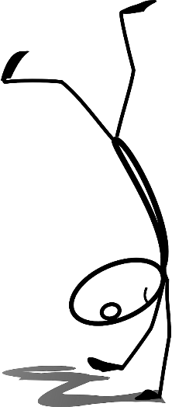

One of the most striking things that I was told by a counsellor many years ago was that I had 2 choices to overcome anxiety… I could either take anti-depressant tablets or I could join the gym. Thankfully I chose the latter and have never looked back!
Now when I`m feeling low, I am able to practice meditation and breathing methods along with performing some exercise to overcome how I am feeling. I would at times experience physical pain purely caused by anxiety and I didn’t want to live like this any longer.
Life can be tough at times and living with an illness brings added challenges and it is up to us to make the most of what we have and help ourselves. Not only has exercise helped me mentally but I`ve found that it`s really improved how my body feels.

I truly believe that my bone density is where it’s at right now because I have practiced using weights over time. By doing lots of repetitions when exercising with light weights, you can improve your bone strength which reduces the chances of injury.
I have also found that Pilates has helped me considerably.
Experiencing lower back pain for many years as a lot of us do, this gentle form of exercise concentrates on strengthening the stomach muscles which in turn strengthen the muscles in the lower back. This can help to prevent strain or injury as well as many other benefits such as relief from stress or tension. It also improves joint mobility, balance, body strength and flexibility.
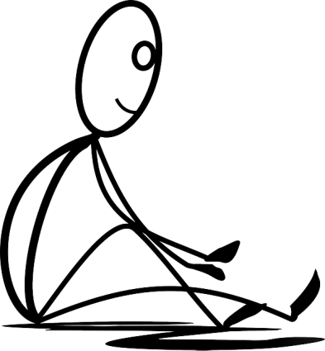
I now walk better, stand better, my bone density has improved in the spine and I`m in less pain!

During lockdown, I haven’t been able to go to a class or the gym so I have started to follow Lucy Wyndham- Read. I found her exercises ideal because her moves are low impact and are all performed standing which is great for me as my knees have become a little painful recently from arthritis so it can be challenging to get to the floor and back up again these days! She has a huge range of videos to follow for every concern and it`s all free on YouTube. She also focuses on keeping the heart healthy and avoids anything high impact to avoid injury. What I also love about Lucy is that her videos are quick and varied. She’s really motivational!
At other times I simply go for a walk in the park to make the most of the fresh air. This also helps me to appreciate nature more which is fantastic for our wellbeing.
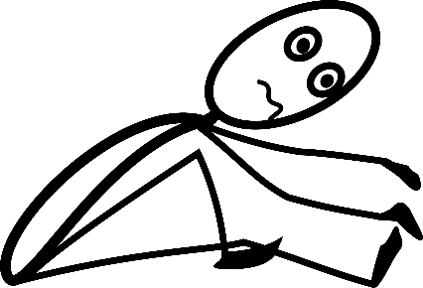
Because I`ve been exercising for many years, I`ve varied the exercises so that it never becomes boring as I`ve grown to understand how beneficial keeping active has been for me. I have adapted the exercises over the years to suit my lifestyle and physical levels. I used to do lots of high impact classes when I was younger and now I`ve found that a gentler form of exercise is more appropriate. There is something we can all do regardless of ability. Even gentle stretches in the morning can help the body relax and release pain.

So, to sum up, exercise helps with…
*improving our mental health and mood
*helps the body manage sugar and insulin control
*builds bone density
*reduces pain
*improves flexibility
*helps the heart muscles become better able to pump blood throughout our body
These are just a few examples of how exercise can benefit patients but there are so many more positive reasons to keep moving.
It can also be very social!
I don’t want to harp on too much but perhaps I have given you something to think about?
A little effort goes a long way!
Until next time…

“Physical fitness is the first requisite of happiness.”– Joseph Pilates

